https://www.perutravelexpertsb.com/tours/lake-humantay

HUMANTAY LAKE – FULL DAY ADVENTURE FROM CUSCO

Discover One of Peru’s Most Spectacular Natural Wonders.
Escape the city and immerse yourself in the breathtaking beauty of Humantay Lake, one of the most stunning turquoise lakes in the Peruvian Andes. Nestled beneath the snow-capped peaks of the majestic Humantay and Salkantay Mountains, this unforgettable journey combines spectacular landscapes, authentic Andean culture, and a rewarding mountain hike.
For centuries, Humantay Lake has held deep spiritual significance for local Andean communities, who regard it as a sacred place connected to nature and the powerful mountain spirits known as "Apus." Today, visitors from around the world come to admire its crystal-clear waters and experience the peaceful energy that makes this destination truly special.
Your Day at a Glance.
Your adventure begins early in the morning with a comfortable pickup from your hotel in Cusco. We travel through picturesque Andean valleys and traditional villages before arriving in Mollepata, where you will enjoy a freshly prepared breakfast at a local restaurant.
After breakfast, we continue to Soraypampa (3,900 m / 12,795 ft), the starting point of our hike. As you ascend through breathtaking mountain scenery, your guide will share insights about the region, its culture, and the surrounding glaciers. The trail includes several opportunities to rest, take photos, and fully appreciate the incredible views.
Upon reaching Humantay Lake (4,200 m / 13,779 ft), you will be rewarded with one of the most spectacular landscapes in Peru. The vivid turquoise waters, framed by towering glaciers and dramatic mountain peaks, create a scene that feels almost unreal. Take your time to relax, capture unforgettable photos, and simply enjoy the tranquility of this remarkable place.
After spending time at the lake, we descend at a comfortable pace back to Soraypampa before returning to Mollepata for a delicious lunch at a local restaurant. In the afternoon, we journey back to Cusco, arriving at your hotel with unforgettable memories of one of the Andes' most iconic destinations.

Travel with Confidence.
Our private tours are designed to provide comfort, safety, flexibility, and authentic local experiences. From the moment we pick you up until your return to Cusco, our team is committed to delivering personalized service and creating unforgettable memories in Peru.

Travel Recommendations.
To ensure you enjoy your Humantay Lake adventure to the fullest, we recommend bringing:
✓ Comfortable hiking shoes or trekking boots with good grip
✓ Warm layers of clothing (temperatures can change quickly in the mountains)
✓ Waterproof jacket or rain poncho, especially during the rainy season
✓ Sun hat, sunglasses, and sunscreen
✓ Reusable water bottle to stay hydrated
✓ Snacks such as energy bars, nuts, or fruit
✓ Camera or smartphone for spectacular photos
✓ Small backpack for personal items
✓ Cash in Peruvian Soles for optional purchases
Altitude Considerations.
Humantay Lake is located at 4,200 m (13,779 ft) above sea level. We recommend spending at least 1–2 days in Cusco before this excursion to help your body adjust to the altitude and maximize your enjoyment of the experience.
Physical Activity Level.
This tour includes a moderate uphill hike of approximately 1.5 to 2 hours. A reasonable level of fitness is recommended. The pace is flexible, and there will be opportunities to rest and enjoy the scenery along the way.
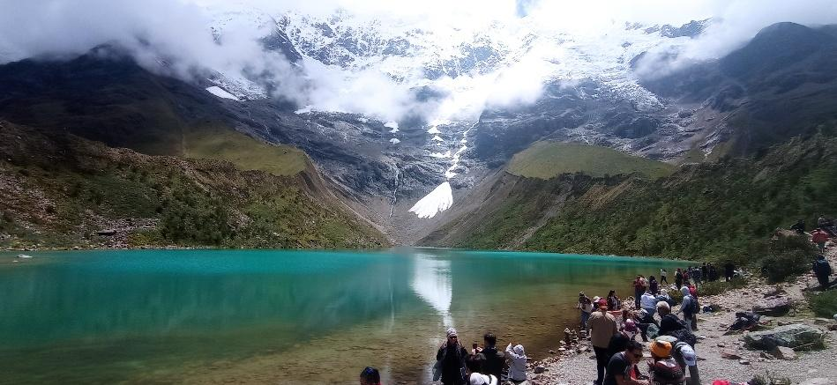
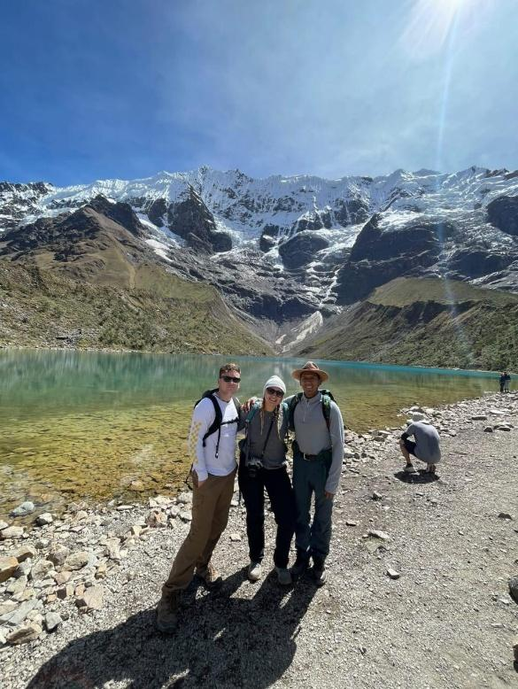

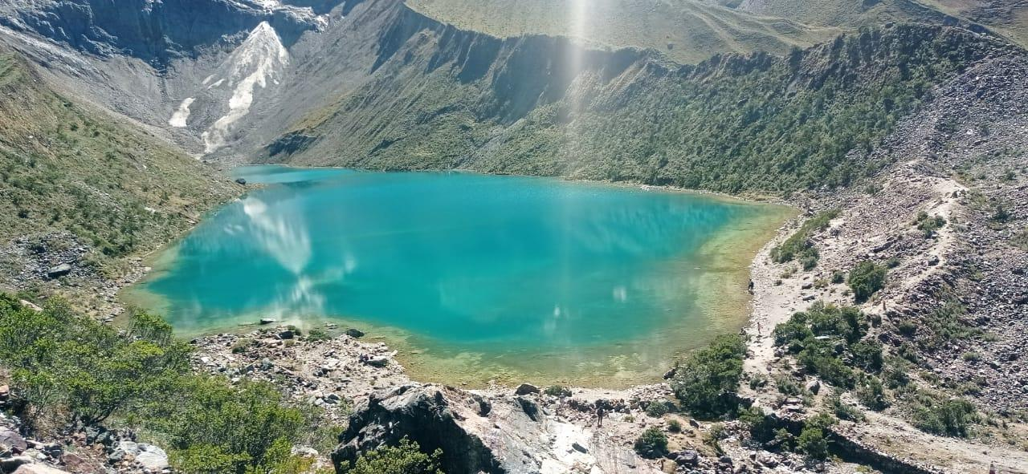

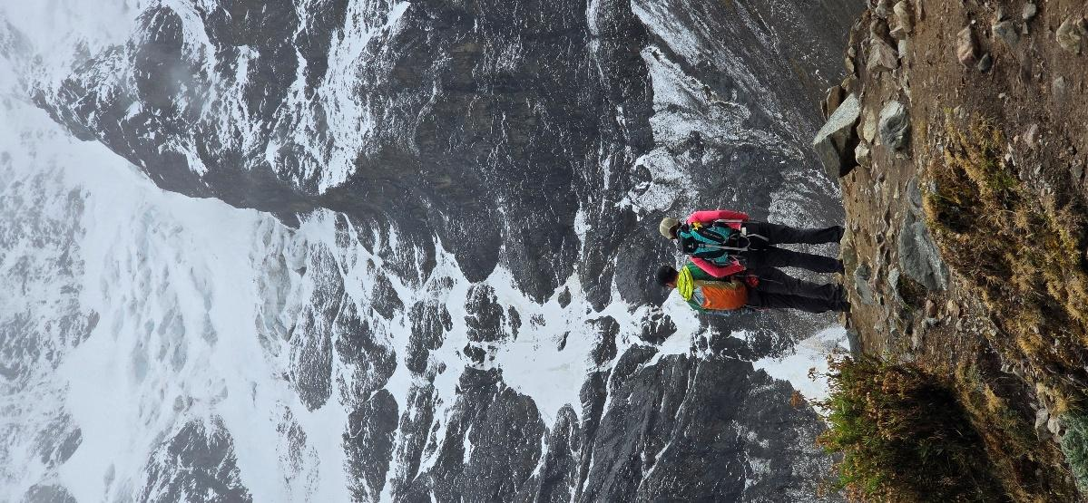

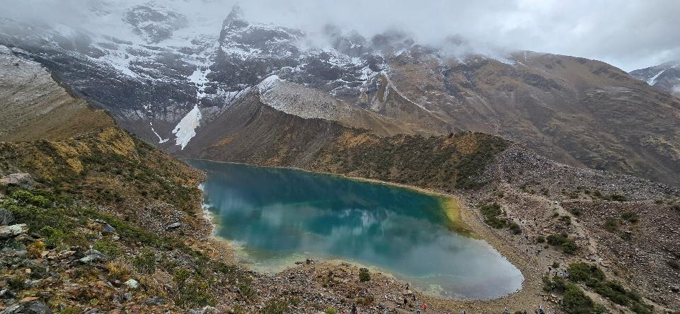

Details of the Day

Departure & Return Location.
Your hotel in Cusco.

Departure Time.
Services start: 04:00 am

What’s Included.
- Pick-up and drop off: at your hotel in Cusco.
- English speaking professional Tour Guide.
- Private Tour.
- Entrance fee to places indicated on itinerary.
- 01 water bottle per traveler.
- Melas: Breakfast and Lunch.

What’s NOT Included.
- Personal expenses and anything other than what is on the program.
- Hotel in Cusco.
- Meals: Dinner
- Gratuities.

Suggestions and Restrictions.
Comfortable walking shoes, Sun Protection or rain ponchos, depending on the season, hat, Snacks, and a lot of
curiosity

Tour Price.
Prices are per person and vary according to the number of travelers in the group.

1-2 PEOPLE | 3 PEOPLE | 4 PEOPLE | 5 PEOPLE | 6 PEOPLE | 7 PEOPLE | 8 PEOPLE
$ 219 | $ 159 | $ 129 | $ 119 | $ 109 | $ 99 | $ 89

